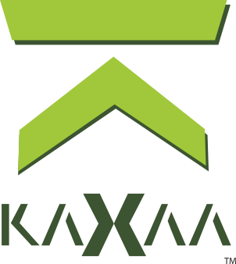

Universal Value of Exchange.
Reimagined.



WHITEPAPER A DISCLAIMER 5
Kaxxa Overview Q & A 6
What is Kaxaa? 6
How many Kaxaa tokens are there in circulation? 6
Who are the founders of Kaxaa? 7
Where can I buy Kaxaa? 7
Introduction and Necessary Background Information 8
What is a Blockchain? 8
Kaxaa is a Unique Blockchain Platform Tied to Real Estate 8
Kaxaa: Liquidity of Crypto - Stability of Real Estate 9
Kaxaa is Stable: Value is Not Set by the Crypto Market 9
Kaxaa Platform is Designed for “Non-Crypto” Users 9
Kaxaa Provides Unique Utility 9
How Kaxaa Works I: Leveraging Crypto & Technology 9
The Kaxaa Index 10
Kaxaa Tokens are “Stabilized” by Real Estate Market Indicators 10
The Kaxaa Market Cap and Issuance of Additional Tokens 11
Above: the Kaxaa Market Cap from April 2023 to April 2025 11
More Detail on Source Indexes
Below: the Real Residential Property Prices for the United States April 2019 to December 2021.
Wyoming: an Oasis for Crypto 11
Immediate Real World Product Deployment 12
Platform Ready Prior to Sale of Kaxaa Tokens 12
The Kaxaa Solution: Based in Polygon 12
Blockchain for Real Estate 13
The Kaxaa Token and Mining in More Detail 13
Kaxaa Token 13
Proof of Stake Smart Contract Validation (“Mining”) 13
Kaxaa Security Components in More Detail 14
Beyond State-of-the-Art Security Standards 14
Kaxaa PiggyBank eWallet 15
The Perfectly Balanced Token 16
The Kaxaa Symbol 17
Marketing 17
Objectives 17
Referral and Growth Programs 18
Kaxaa Token Growth Pool 18
Calendar Canvassing and Social Media 18
Influencer Marketing 18
Broker Incentives 18
Kaxaa Planet Fund 18
Project Roadmap 19
Current Projects: Q3 2023 & Q3 of 2024 19
Kaxaa Platform Completion 19
Kaxaa BlockVersionTM Security Integration 19
Token Sale 19
The Kaxaa Team 19
Kaxaa Key Leadership 20
Mohammad Ali - Solution Architecture & Technical Development 20
Nene Gonzalez – Development & Execution Strategy 20
Vaughn Smith – Project Vision & Corporate Structure 20
Whitepaper A Appendix: Utility Token vs. Security
Is the Kaxaa Token a “security” as defined by the Act and the Law?
Kaxaa sale 21
Kaxaa: Liquidity of Crypto - Stability of Real Estate 23
Value of Kaxaa Not Set by the Crypto Market 23
Real Asset Acquisition Model 23
How Stakeholders May Participate 24
Regulatory Compliance Reduces Risk 24
Kaxaa KYC Chain 24
Glossary of Terms 24
Important Links 25

WHITEPAPER A DISCLAIMER
Use of This Information at Your Own Risk
This whitepaper and all other publications, press releases, discussions and other media, or any statement whatsoever in any form, released by Kaxaa Tech LLC, it’s directors, subsidiaries, and related parties (“Documents”) are created by and are the sole property of Kaxaa Tech LLC, or the Kaxaa Entities, based in Sheridan, Wyoming, and its subsidiaries and partners (collectively and separately referred to herein as “Kaxaa”) and are intended solely for review and discussion by the blockchain and cryptocurrency and other communities regarding the technological merits of the potential system outlined herein. This whitepaper contemplates and discusses possible terms of, but Kaxaa specifically does not make, an offer to buy or sell crypto tokens, or other opportunity. All information related thereto are for informative purposes only and all representations herein are not to be relied upon whatsoever. Kaxaa makes no representations or warranties (whether express or implied), and disclaims all liability arising from any information stated in the Documents. The actual results and the performance of Kaxaa may differ materially from those set out in the Documents.
Kaxaa is completing a functioning Kaxaa Platform however the Documents make no binding representations or warranties about this platform. No regulatory authority, in any jurisdiction, has examined or approved of any of the information set out in the Documents. Thus, no action has been or will be taken under the laws, regulatory requirements, or rules of any jurisdiction. The publication, distribution, or dissemination of the Documents do not imply compliance with any applicable laws, regulatory requirements or rules whatsoever and no reliance on this should be made by anyone at any time. Token sales will not be used to build the Kaxaa Platform.
Please refer to the Terms and Conditions at Kaxaa.com, or other registered domains held and operated by Kaxaa (“Website”) for additional terms and conditions. Nothing in the Documents or Website should be considered an offer or legally binding document, nor shall it ever constitute legal or financial advice and no attorney-client relationship is formed. You should consult with an attorney or other professional to determine what may be best for your individual needs. Your use of the Documents or any materials from the Website is at your own risk.
Though the will be based on the sale and utilization of a stabilized Utility Token and is expected to be immediately redeemable on an active exchanges, usable in transactions between parties, and on the Kaxaa Platform, Kaxaa is seeking to protect token holders by limiting or blocking token sales in jurisdictions where such transactions are limited, restricted or otherwise banned -- reducing the risk of regulatory devaluation.

Kaxaa brings the practical, everyday utility of a real-estate-referenced network to the liquidity and accessibility of blockchain technology — a tool for transacting, not an investment.



PREFACE

Kaxxa Overview Q & A

What is Kaxaa?
Kaxaa is the native utility token of the Kaxaa blockchain network. KAX carries no economic rights and is not backed by, and does not represent any claim on, real estate assets or any other property; its market price is determined solely by supply and demand. The Kaxaa Index, a synthetic index of real-estate and economic data, is used only as a reference point for pricing certain functions of the Kaxaa network. Kaxaa Tokens are intended for use within the Kaxaa Platform and in transactions between parties who wish to use them.
Kaxaa is a Utility Token that is used for:
- Stabilizing crypto-based real estate transactions.
- Participation in data exchange and Kaxaa Platform application access.
- Protection against “Pump-and-Dump” and other price manipulations by institutions or large token holders.

Kaxaa tools includes:
- Kaxaa SDKs which includes standard data structures and testing tools.
- Gitpod for Kaxaa to create a zero time onboarding experience for developers.
- Kaxaa PiggyBank Wallet creates self-custodial assets for streamlined user experience.

How many Kaxaa tokens are there in circulation?
Kaxaa is projected to launch on Q4 2026 with a circulation of ~10,638,298 Kaxaa Tokens created at genesis. The supply may be expanded or contracted according to a fixed, programmatic, and nondiscretionary protocol tied to network usage, with new Kaxaa Tokens being issued or burned to support the functioning of the network. No person or entity exercises discretion over this process, and it is not tied to the value of any real estate asset portfolio.

Who are the founders of Kaxaa?
Kaxaa is a commodity utility token for real estate and platform founded by a diverse team of subject matter experts in media, marketing, real estate, finance and technology. The team includes Nene Gonzalez, Vaughn Smith, and Mohammad Ali. The Kaxaa project has fostered the collaboration of more than 20 technical teams from around the globe, including developers with experience in highly complex decentralized media and finance technologies.

Where can I buy Kaxaa?
Kaxaa will be available for trading on QuickSwap, Rango Exchange, and Uniswap decentralized
exchanges and through the Kaxaa wallet (PiggyBank) utilizing WalletConnect extension. The
Kaxaa token will be available under the ticker “KAX.” The On & Off Ramping of the KAX token
can be executed through our money transfer partner Stripe for on and off ramping of crypto to
fiat.

What is the Exchange Strategy?
Traditional centralized exchanges (CEXs) provide confidence and stability which lends itself well
to the rollout of stabilized blockchain projects. The principals intend to offer Kaxaa Tokens on
multiple exchange platforms.

In contrast to CEXs, and in the absence of intermediaries, DEXs takes on a non-custodial
framework. This means that the holder retains custody of the digital assets and are
directly responsible for managing their web3 Kaxaa wallets and private keys. Holding your
private keys is considered a boon to users who want to maintain complete control of their
assets.

Introduction and Necessary Background Information

What is a Blockchain?
Blockchain is the most exciting, disruptive, and revolutionary technology since public adoption of the Internet. A blockchain is a public electronic ledger that can be openly shared among disparate users and that creates an unchangeable consensus-driven record of their transactions. A large number of computers are connected to the network, and to reduce the ability for an attacker to maliciously add transactions on the network, those adding to the blockchain must compete to solve a mathematical proof. The list of transaction records, called blocks, continuously grows are linked and secured using cryptography. Each block typically contains a cryptographic hash of the previous block, a timestamp and transaction data. By design, a blockchain is inherently resistant to modification of the data. It is an open, distributed ledger that can record transactions between two parties efficiently and in a verifiable and permanent way. For use as a distributed ledger, a blockchain is typically managed by a peer-to-peer network collectively adhering to a protocol for inter-node communication and validating new blocks. Once recorded, the data in any given block cannot be altered retroactively without the alteration of all subsequent blocks, which requires collusion of the network majority. Because of this, the blockchain contains a true and verifiable record of each and every transaction ever made in the system. Blockchain allows for the recording and verification of transactions for virtually anything of value and, when combined with other information assets, becomes an incredibly powerful tool on which to build secure content and value exchanging ecosystems not previously possible.

Kaxaa is a Unique Blockchain Platform Tied to Real Estate
Kaxaa (pronounced “Ka-sa”) is a blockchain platform consisting of three main elements: the Kaxaa Token, based on the Kaxaa Index and the Kaxaa Platform. Kaxaa will use Smart Contracts sitting on the Polygon Chain, Ethereum blockchain system network. Kaxaa Tokens are priced solely by supply and demand; the Kaxaa Index, an algorithmic weight of real world real estate indexes, is used only as a reference point for pricing certain functions of the Kaxaa network, and KAX is not backed by, or convertible into, any real estate asset. Kaxaa Tokens will be freely tradable and usable like a “currency” in transactions between parties and for trade on open exchanges. Kaxaa connects token holders and other stakeholders to real world market value indicators in a more substantial and permanent way than typical volatile speculative crypto projects. Kaxaa is the vehicle for the convergence of the emerging new generation of token holders who are open to new technologies and better ways to do things.

Kaxaa: Liquidity of Crypto - Stability of Real Estate

Kaxaa is Stable: Value is Not Set by the Crypto Market
Like all crypto assets, the market price of the Kaxaa token is determined by supply and demand. Kaxaa's tokenomics, including token issuance and burn, are programmatic and nondiscretionary, so there is no organizational effort by Kaxaa or its affiliates to prop up or manage the trading price of KAX. The service fees charged for use of the Kaxaa network reference the Kaxaa Index, a synthetic measure of real-estate and broader economic data, which may make demand for KAX somewhat sensitive to conditions reflected in that Index; however, there is no guaranteed or hard link between the Index and the market price of KAX. Typical crypto assets are highly volatile and carry significant valuation risk during the time real estate transactions require to be completed. Holders of Bitcoin, Ethereum, and other cryptos may convert their holdings to Kaxaa Tokens which can provide a more stable and far less likely to fluctuate dramatically during the transaction timeline. A separate entity holds a portfolio of real estate assets; proceeds from that portfolio may be used to fund the operations of Kaxaa Tech LLC and the token issuer, but that entity plays no role in, and its assets do not back or secure, the Kaxaa network or the Kaxaa Token as such.

Kaxaa Platform is Designed for “Non-Crypto” Users
Kaxaa is an ideal platform for first time crypto users. Kaxaa is being integrated into simple technologies for even the most novice crypto enthusiasts or first time crypto users to quickly understand their position, new opportunities, and more. The Kaxaa Platform represents a straight-forward and simple step-by-step tool for novices to engage in easy exchanges and a limited and streamlined experience which doesn’t overwhelm users or confuse them by presenting hundreds of confusing procedures or assets on-screen at once.

Kaxaa Provides Unique Utility
Kaxaa is an incredibly flexible digital system with freely tradable tokens that provide liquidity similar to any hard real world asset or currency. Token holders may choose to acquire Kaxaa Tokens may use them in third party transactions as a “stabilized” currency, or convert them using the Kaxaa wallet. Kaxaa Token holders may also use Kaxaa Token to access proprietary data and features within the Kaxaa Platform. Such users may sell or transfer KAX to third parties in the same way they would any other digital currency. This flexibility is not common in traditional real estate. Though Kaxaa Tokens are not intended, marketed, or sold as a vehicle for appreciation, hedging against real estate prices, or profit from the efforts of Kaxaa or any other party, buyers should not expect to profit from holding Kaxaa Tokens, and the market price of KAX is set solely by supply and demand.

How Kaxaa Works I: Leveraging Blockchain Technology

The Kaxaa Index
Kaxaa is a community token system tied to key real estate indexes, the Kaxaa Real Estate Index – or Kaxaa Index. The Kaxaa Tokens offer stability and liquidity uncommon with typical crypto projects. The Kaxaa Index is a patent-pending technology that produces an overall real estate health status expressed as a single number which will be valued, maintained and published by a third party auditing firms. Third party auditing and validation ensures reliable and trustworthy custodianship of the Kaxaa Index. The Kaxaa Index shares similarities with the Financial Times Stock Exchange Group NAREIT Equity REIT Index in that it is a proprietary index which tracks a variety of data sources to produce an overall market health indicator. The Kaxaa Index also considers the overall valuation of Kaxaa’s brick-and-mortar real estate businesses and market sentiment in its calculation.

Kaxaa Tokens are “Stabilized” by Real Estate Market Indicators
In real estate, price indices are designed to illustrate the status of the commercial and residential real estate markets. Kaxaa’s uses a proprietary algorithm to weigh market indicators which results in a new index, the Kaxaa Index. The freely tradable Kaxaa Token is tied to a weighted result of real estate global value indexes including: the S&P/Case-Shiller U.S. National Home Price Index, Swiss Real Estate Price Index (SRED), URA Private Residential Property Index, VDP Property Price Index, Teranet-National Bank House Price Index, and CoreLogic Home Value Index which is used to indicate market volatility and confidence. The Kaxaa Token itself carries no claim on, and is not backed or secured by, any real estate assets; the Kaxaa Index is used only as a reference point for pricing functions of the Kaxaa network, and the market price of KAX is determined by supply and demand.

Below: the Kaxaa Index from April 2024 to April 2025
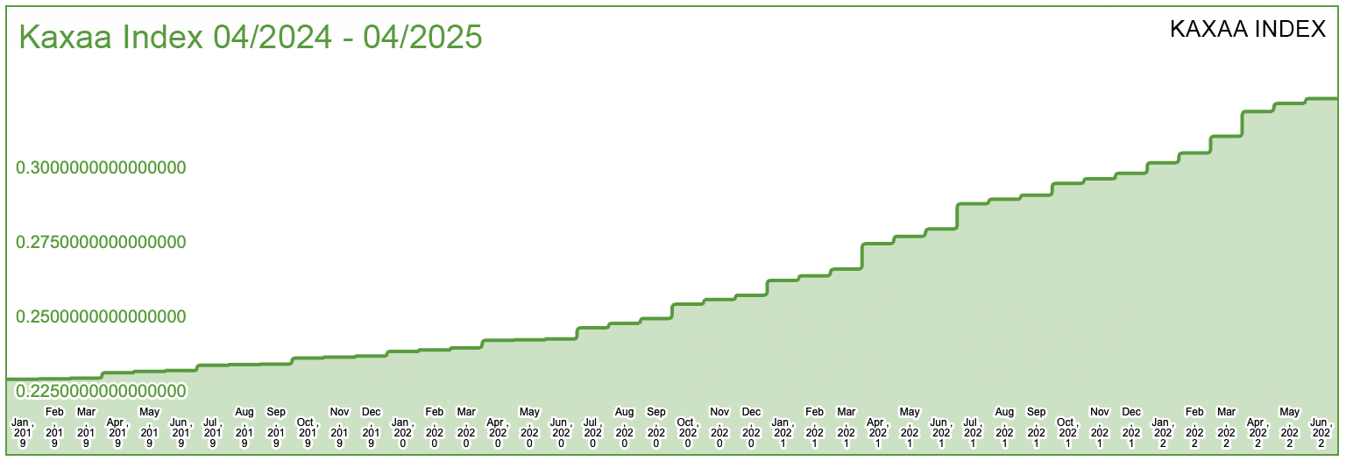
The Kaxaa Index Algorithm in More Detail
Kaxaa is directly connected to retrieve index and market indicator data from the Federal Reserve Bank of St. Louis; https://fred.stlouisfed.org/.
The Kaxaa Index represents a similar concept as the “Gold Standard” and represents a
weighted and blended measurement of index data supplied by the six strongest and most
stable countries for holding real estate assets, due to their strong economies, political
stability, transparent legal systems, and resilient property markets. These indexes have a
combined average (using modified root mean square method) with a relative weight of ~52% of
the Index Average value. The other market indicator data such as the Interest Rates and Prices
Indexes, Real Residential Property Prices, and the All-Transaction House Price Index are
balanced using multipliers and a combined average is calculated (using modified root mean
square method) with a relative weight of ~48% of the Index Average.
The square root of a set weighted average of the Index Average and the Kaxaa portfolio value produces the Kaxaa Index value. Currently the Kaxaa portfolio value substantiates ~3% - 5% of the Kaxaa Index value while market factor and index data constitutes the remainder.
The real estate portfolio values and their influence in the calculation of the Kaxaa Index does not indicate the liquidity of the assets, they are simply used to influence the overall Kaxaa Index as a small proportion to the overall market indicators.

The Kaxaa Market Cap and Issuance of Additional Tokens
The Kaxaa market cap is the market price of KAX, as set by supply and demand, multiplied by the number of issued Kaxaa Tokens. Issuance and burn of additional Kaxaa Tokens is governed by a programmatic, nondiscretionary protocol tied to network usage, not by any pledge or contribution of real estate assets, so that no person or entity can exercise discretion over the supply of KAX.
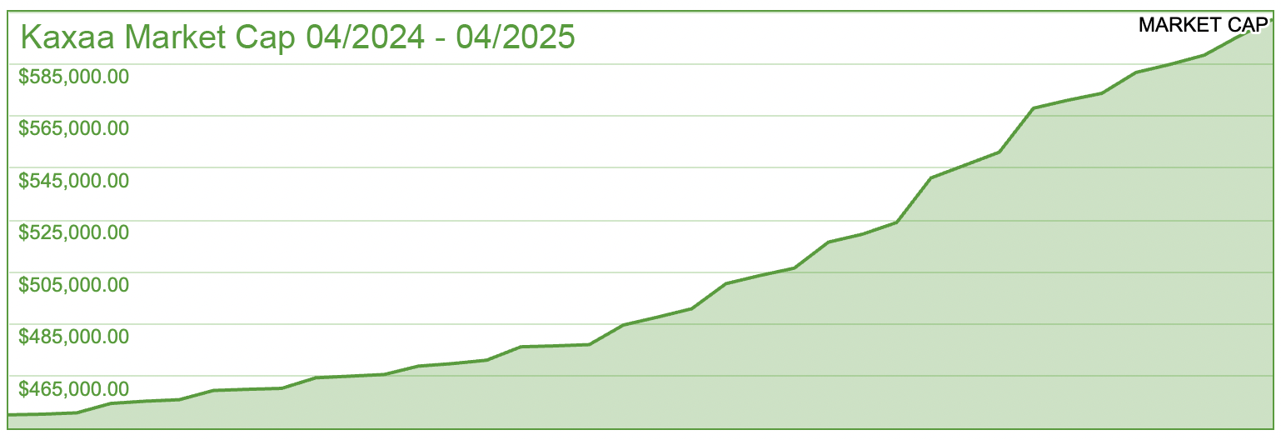

Above: the Kaxaa Market Cap from April 2024 to April 2025

Wyoming: an Oasis for Crypto
Wyoming is leading the way in cryptocurrency legislation and is a tax haven for crypto base companies. Wyoming has enacted more than two dozen laws in the last few years designed to protect and support cryptocurrency companies. In 2021 alone the state passed 13 laws for the protection of crypto companies and their leaders. Kaxaa’s legal and corporate structures for real world real estate holdings are established out of Wyoming with initial real estate projects occurring in Florida, Arizona, Indiana, and Georgia. Wyoming is the ideal U.S. domicile for legal structures due to the state’s progressive legislation for crypto companies, tax incentives, strong partner and corporate privacy laws. Wyoming laws also makes Bitcoin and other cryptocurrency transactions exempt from transmitter regulations. Wyoming’s legislature has ensured that cryptocurrency transactions will likely remain free of state taxes, including sales tax and property tax.
As noted elsewhere in this document, Kaxaa has prepared the filing of an Open Blockchain Token – Notice of Intent with the Wyoming Secretary of State pursuant to W.S. 34-29-106(c).

The Kaxaa Solution: Based in Polygon

Link to Polygon Scan: https://polygonscan.com/address/0x42aF7aAc6AE6425Ffa96370cFD0B12522Aa4b458

The Kaxaa Token and Mining in More Detail

Kaxaa Token
The Kaxaa smart contract (token) is built on the Ethereum Network, on the Polygon protocol chain (Layer 2). Polygon is the fast and gas eﬃcient widely supported smart contract blockchain, with a huge development community and robust language support. Kaxaa has evaluated the available technologies and Polygon has a strong future development and is likely to be ideal in creating the new decentralized Internet. Gas fees and mining fees on the Polygon network are extremely low in comparison to others, particularly Ethereum. Ethereum network gas and mining fees are famously high and sometimes make it impossible for some Ethereum token holders to exit positions. This is a primary reason for Kaxaa’s choice to harness the efficient power of the Polygon network.

Proof of Stake Smart Contract Validation (“Mining”)
As part of the Kaxaa Token and ecosystem; Validators will confirm Smart Contracts related to these activities and earn Kaxaa Tokens for their efforts on a Proof of Stake (PoS) basis when new valid blocks are forged on the Polygon Validation Consensus community.

Kaxaa Security Components in More Detail

Beyond State-of-the-Art Security Standards
Just like with other non-crypto data systems used by banks, retail points systems, credit card companies, apps, and stock platforms, theft and cyber-attacks are among the greatest risks to Kaxaa and its participants. Kaxaa utilizes beyond state-of-the-art systems and technology to protect the Kaxaa blockchain and data ecosystem from attacks with methods and systems proven to offer the greatest protection as used by other secure providers such as banks. Each transaction within the system will be encrypted end-to-end with assets and data encrypted at rest (while being stored) and in transit (while being sent between systems and users) with always-on monitoring for malicious activity or system errors.

Kaxaa BlockVersionTM Security Integration
In conjunction with other security protocols and technologies, Kaxaa will launch Kaxaa’s custom digital product which will employ a “version control” concept of security where, in the event of a security breach (“hack”), the blockchain may be restored to the “version” immediately prior to the fraudulent transaction(s). A process for electing a neutral Board of Security Advisors will be established to determine this procedure and version restoration in such an event.

Kaxaa Policies and Procedures Ensure Security
Digital security is more than protection technologies; real security requires robust operating procedures and behavior requirements for vendors, employees, contractors and anyone who interacts on any level with the Kaxaa technology stack. Kaxaa security policies and procedures, specifically designed for stalwart defense against malicious actions, include: cryptographic key management procedures for its blockchain systems, capacity management policies, blockchain and system change management control policies, ultra-redundant data backup policy procedures, blockchain and data classification policies, access classification policies, and ultra-redundant disaster recovery.

Kaxaa: More than a Token

Kaxaa May Stabilize Crypto Real Estate Transactions
Kaxaa Tokens may be used to stabilize transactions where purchases of property desire to use crypto for earnest payments and other deposits, even purchasing property outright using crypto. Crypto currencies are currently being used to progress real estate transactions. Though this is exciting, typical crypto assets are highly volatile and carry significant valuation risk during the time of escrow and other transactional processes. Holders of Bitcoin, Ethereum, and other cryptos may convert their holdings to Kaxaa Tokens which is far less likely to fluctuate dramatically during the transaction timeline.

Emerging Technology Means Opportunity
The blockchain technology is only in its infancy stage, everyday being adapted by more governments, public and private sectors, and changing the approach of how we manage personal life and professional business. Blockchain is here to stay and to improve outdated practices and this new technology means a huge opportunity for growth.

Why Do Some “Stable” Tokens Collapse?
There is no way to avoid the recent news all over the crypto and finance world of the TerraUSD, an algorithmic stablecoin whose peg mechanism relied on an associated crypto asset rather than any external reserve. That episode is a reminder that a token designed to track an external reference through a hard peg or reserve can fail if that mechanism breaks down. Kaxaa takes a different approach: KAX is not pegged to, backed by, or redeemable for real estate or any other asset, and its market price is set solely by supply and demand. The Kaxaa Index is used only as a reference point for pricing certain network functions, and demand for KAX may be influenced, but is not guaranteed to track, the level of that Index. As with any crypto asset, the price of KAX can fluctuate, and Kaxaa makes no representation that KAX will maintain a stable value or appreciate over time.

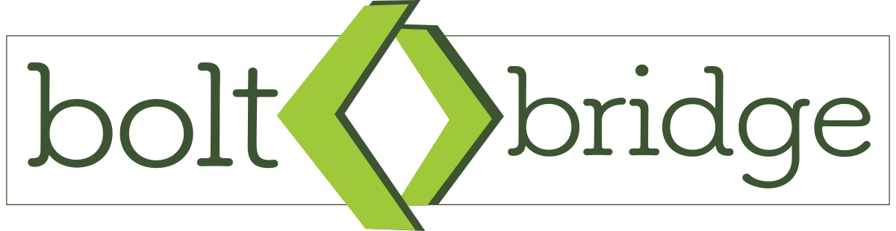
​
Kaxaa PiggyBank™ is a multi-chain, decentralized, self-custodial Web3 wallet that integrates a proprietary zero-knowledge Layer 2 (L2) technology called Bolt-Bridge. This integration facilitates seamless interoperability bridge between public and private blockchain networks, enhancing both scalability and privacy for users.
The integration of Bolt-Bridge into PiggyBank offers several key benefits:​
- Hybrid Chain Compatibility: Bolt-Bridge allows PiggyBank to operate across both public and private blockchains, providing users with a unified platform to manage diverse digital assets.​
- Scalability: By offloading transaction processing to a Layer 2 solution, Bolt-Bridge reduces the load on the main blockchain (Layer 1), leading to faster transaction times and lower fees. ​
- Enhanced Privacy: Zero-knowledge proofs ensure that transaction details remain confidential, which is particularly beneficial for users engaging in sensitive financial activities.​
- Security: The trustless nature of ZKPs minimizes the need for intermediaries, reducing potential points of failure and enhancing the overall security of cross-chain transactions

Kaxaa PiggyBank™ integrates AI-powered support through Chatling.ai, delivering real-time, conversational assistance directly within the wallet interface. This intelligent assistant guides users through onboarding, wallet setup, transaction management, and advanced features like Bolt-Bridge, all while simplifying complex Web3 interactions. With natural language understanding, Chatling.ai answers questions, resolves issues, and provides step-by-step navigation tailored to each user’s needs.
Seamlessly embedded in the PiggyBank UI, Chatling.ai offers 24/7 multilingual support, proactive troubleshooting, and personalized insights—without compromising user privacy. Whether bridging assets, troubleshooting failed transactions, or managing hybrid-chain activity, users get instant, intuitive help that makes the Kaxaa experience smoother and more accessible.

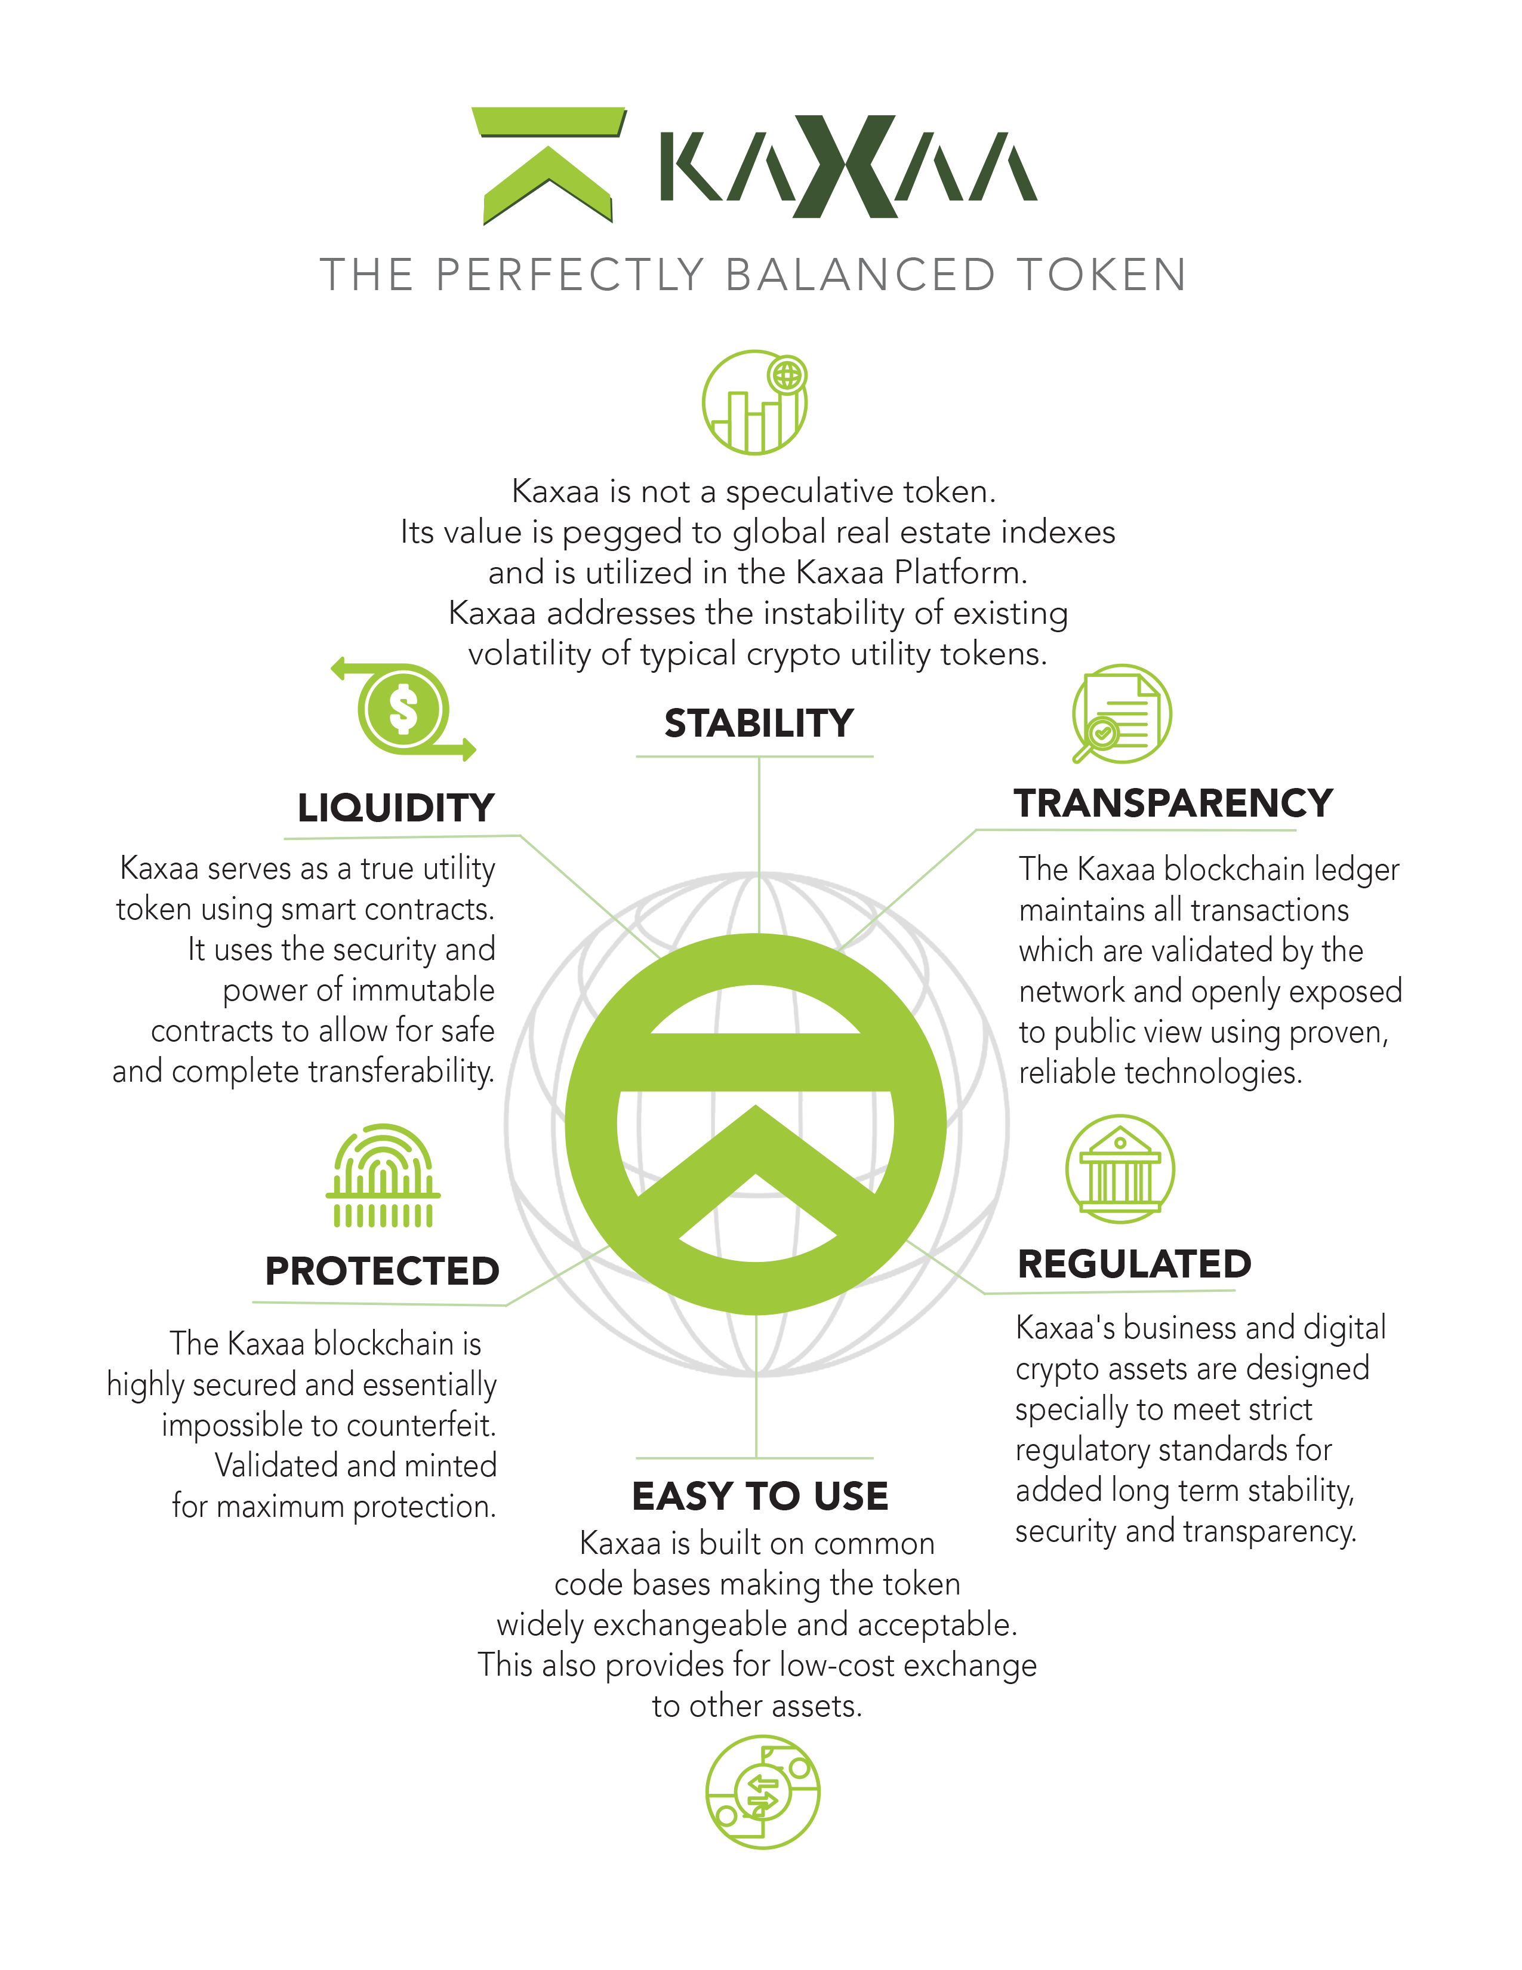

The Kaxaa Symbol
Kaxaa (Latin word for “home”). The Kaxaa logo symbol is a tribal looking “K’” in shape of the top roof of a house. Optionally (and preferably) the symbol may have a circle around it. This symbol (including the circle around the “K” graphic) is trademarked with the United States Patent and Trademark Office pending publication and registration, and used under license by Kaxaa, at the time of this document.

 Left: REF. - The Kaxaa Symbol (simplified) Left: REF. - The Kaxaa Symbol

Initial Token Minting and Distribution
10,638,298 Kaxaa Tokens will be created initially with 1 Kaxaa (KAX) valued at ~$0.47.

Minting and Burning of Tokens to Control Value
Kaxaa Tokens may be minted in the future beyond the initial release, and Kaxaa Tokens held in reserve may be burned, in each case according to a fixed, programmatic, and nondiscretionary protocol tied to network usage. No person or entity exercises discretion over minting or burning, and neither mechanism is designed or intended to manage, support, or prop up the trading price of KAX.

Marketing
Kaxaa will focus brand and product awareness on reaching the worldwide real-estate enthusiast and professional audience through promotion of use case success stories, early opportunity promotions, and philanthropic climate protection efforts that will be woven into the brand. Initially, Kaxaa may use project updates for early crypto companies to track updates. Kaxaa will also employ Social media, conventional PR, and other viral strategies will be developed to amplify awareness and eventual adoption.

Objectives
- Attract Early Adopters, Supporters, and Influencers to Generate Awareness
- Transform Awareness into Buzz, Interest, and Community
- Establish Kaxaa as the dominate brand synonymous with crypto real estate

Calendar Canvassing and Social Media
Kaxaa will publish regular calendar updates through popular calendar services covering crypto, such as ICOCountdown, ICObench, tokenMarketCal, and tokendar, and also to services specifically covering airdrops, such as AirdropsAlert or Airdrops. These regular postings will also be bolstered by an aggressive social media program covering updates about project progress, promotions, success use case stories, deal news, and transactional news, among others.

Influencer Marketing
There are many prospective influencer partners to work with to reach their online audiences across cryptocurrency, real estate, climate change, and other arenas. Consumers and industry peers alike all look to influencers on YouTube and other social networks for information on the next big thing, deep dives into how new projects work, and much more. We will be profiling and targeting key influencers to cover Kaxaa and reach their audiences to build our community.

Real Estate Brokers
Kaxaa’s role as a real estate oriented currency will be forged through the exchange of real world property assets involving real estate brokers, title companies, and holders of other crypto who desire to engage in more stable transactions. Kaxaa will forge strong relationships with real estate professionals through rewards and incentives in Kaxaa Tokens to encourage adoption and use of the Kaxaa network. These rewards and incentives are for services rendered and are not intended to affect, and should not be understood as an effort to affect, the trading price of KAX.

Kaxaa Planet Fund
Kaxaa will be developing a fund to purchase and protect land and natural resources under the Kaxaa Planet Fund, a non-profit element of our strategy. We all have only one home, Planet Earth, and the protection of its resources and health is beneficial for everyone. This will be a part of the Kaxaa brand. This fund will have Kaxaa Tokens allocated among other means to fund its activities. This effort will be tied to a global public relations program to allow anyone to sign up and receive a part of protecting these resources. Rather than the right to sell, the owners of the Tokens will have voting rights on expanding protections, allocating new funds coming up and voting on where to possibly allocate resources. Communities around the world will be able to submit candidate projects from their own communities for consideration to the Kaxaa Planet Fund.

Project Roadmap

Current Projects: Q3 2023 – Q3 of 2026

Kaxaa Platform Completion
Kaxaa is implementing Core Smart technologies as a base for the Kaxaa Platform which is currently being developed for deployment. The Kaxaa Platform will integrate with the Kaxaa Contracts (Smart) and Kaxaa Contracts (Smart) to store actions, behaviors, transactions, and sharing data for the tokens and act as a base for wallet technologies.

Kaxaa BlockVersionTM Security Integration
Theft and cyber attacks are among the greatest risks to Kaxaa and its participants. Kaxaa utilizes beyond state-of-the-art concepts and technology to protect the Kaxaa blockchain and data ecosystem from attacks. Kaxaa security policies and procedures, specifically designed for stalwart defense against malicious actions, include: cryptographic key management procedures for its blockchain systems, capacity management policies, blockchain and system change management control policies, ultra-redundant data backup policy procedures, blockchain and data classification policies, access classification policies, and ultra-redundant disaster recovery.
Kaxaa is developing its platform beyond state-of-the-art database, Polygon server, and real estate technologies. The following roadmap is provided in key deployment milestones and based on the current state of the technology and beyond state of the art expectations.
In conjunction with other security protocols and technologies, Kaxaa will launch Kaxaa’s custom digital product which will employ a “version control” concept of security where, in the event of a security breach (“hack”), the blockchain may be restored to the “version” immediately prior to the fraudulent transaction(s). A process for electing a neutral Board of Security Advisors will be established to determine this procedure and version restoration in such an event.

Target: Q4 of 2026

Token Sale
The Initial Sale of Kaxaa Tokens will be followed by an Initial Release and Launch Release of the Kaxaa PiggyBank wallet.

The Kaxaa Team
The Kaxaa team is made up of seasoned and successful entrepreneurs with scientific, technical and financial expertise, backed with decades of experience in technology and real estate.

Kaxaa Key Leadership


Nene Gonzalez – Development & Execution Strategy
Nene has a diverse career in marketing in the media industry. Nene developed a proprietary data center for crypto mining and is an investor in an array of crypto exchanges. He began his career at EMI/Capitol Records working with top executives there to elevate name brand musical talent including Selena, Garth Brooks, The Beach Boys and other priority acts. In 1998 Nene founded SER International, a global agency, whose portfolio included international brands such as Casio, Toyota, AARP, and more.


Vaughn Smith – Project Vision & Corporate Structure
Vaughn is an innovative inventor with claim to numerous intellectual properties in technical applications including social media, content recommendation, DRM, and virtual reality. Mr. Smith was an early stakeholder in projects at the intersection of media and technology. Vaughn was a key architect and founder of the first social media driven content streaming platform using pre-crypto token and reward points redemption systems. Recently Vaughn exited his position in an enterprise he co-founded which served as a preferred international technical services and content provider to iTunes, Amazon and dozens more.


Mohammad Ali - Architecture & Technical Development
Mohammad is an innovative professional engineer with highly tuned expertise in creating, mentoring and managing cross functional diverse technology teams. For more than a decade Mr. Ali has led teams through the complex development and execution of large scale LTE and 4GT enterprise media deployments, multi-screen customer and engagement technologies, and peer-to-peer systems for global markets. Ali specializes in building and directing teams for the invention and ongoing growth of digital products, strategic initiatives, and valuable intellectual properties.

Whitepaper Appendix: Regulatory Status of the KAX Token
This appendix summarizes the conclusions of an opinion prepared by outside counsel regarding the U.S. federal securities and commodities law treatment of the KAX token, based on the design of KAX and the Kaxaa network as understood by counsel at the time of the opinion. This summary is for informational purposes only, is not legal advice to any reader, and does not create an attorney-client relationship between counsel and any reader. The underlying opinion is expressly conditioned on the accuracy of the facts on which it relies; if the actual design or operation of KAX or the Kaxaa network changes, or differs from what is described in this Whitepaper, the opinion summarized below should not be relied upon.

Is KAX a Security?
Because KAX carries no economic rights and is intended solely as the native token used to access and pay for functions of the Kaxaa network, counsel has concluded that KAX is properly characterized as a "digital commodity" rather than a security. Under the Howey test, an asset is an "investment contract" (and therefore a security) only if a buyer invests money in a common enterprise with a reasonable expectation of profit derived predominantly from the essential managerial efforts of others. Counsel's opinion is that this standard is not met because: KAX is not offered or marketed on the basis that buyers can expect to profit from its appreciation; the market price of KAX is determined solely by supply and demand rather than by the efforts of Kaxaa, the Issuer, or any other promoter; and the Kaxaa network is designed to be "functional," meaning it has no central party that oversees participation in, or distributes rewards from, the network. On that basis, a purchaser of KAX would not reasonably expect to profit from the managerial or entrepreneurial efforts of others, and KAX would not be a security requiring registration with the SEC.

Is KAX a Swap or Other CFTC-Regulated Instrument?
Separately, counsel considered whether indexing certain Kaxaa network service fees to the Kaxaa Index would make KAX a "swap" or other instrument regulated by the CFTC. Counsel's opinion is that it would not, because the market price of KAX is set by supply and demand rather than by a hard link to the Kaxaa Index, and because the use of an index to price network service fees is analogous to customary commercial and consumer agreements that reference an index (such as escalation clauses in service agreements), rather than a risk-transfer arrangement between identifiable counterparties of the kind Congress intended to regulate as a swap. Counsel notes, however, that because KAX would be treated as a digital commodity, it would in any event remain subject to the CFTC's antifraud rules applicable to digital commodities.

Conditions to This Analysis
Counsel's opinion that no registration is required with the SEC or CFTC is conditioned on, among other things: (i) the marketing and sale of KAX never suggesting that buyers can profit from its appreciation, or that holding KAX allows a buyer to hedge against real estate prices; and (ii) the Kaxaa network continuing to qualify as a "functional" network that lacks a central party overseeing participation in, or distributing rewards from, the network. Kaxaa intends to operate consistently with these conditions. This summary reflects counsel's analysis as of the date of this Whitepaper, is subject to change based on future facts, regulatory developments, or judicial decisions, and is not a guarantee that any regulator will reach the same conclusion.

Kaxaa: Liquidity of Crypto - Stability of Real Estate

Below: the Kaxaa Index from January 2012 to April 2023

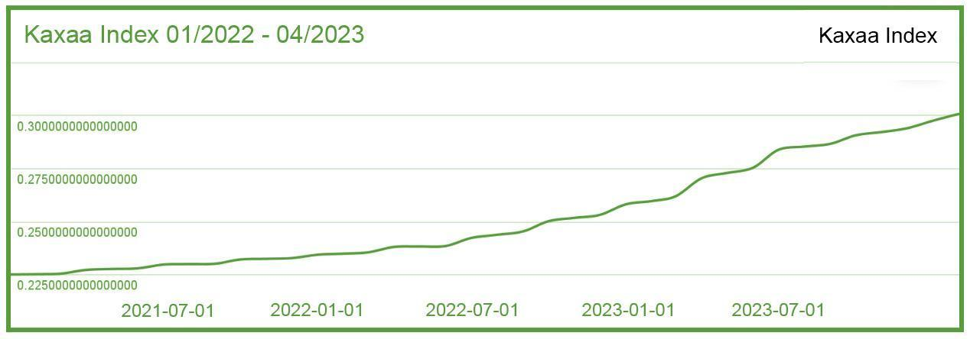

Initial Real Asset Acquisition Model (model only illustrates the U.S.)
The initial asset acquisition portfolio model for Kaxaa is based on low-risk, multi-unit
property acquisitions. The metrics are measured on price-to-value, while hedging against
vacancies, evictions, renovation down time, and other issues which can affect the rental
revenue stream. The apartment, condo and small commercial unit acquisitions are
executed to maximize the rental revenue and minimize the liability exposure. Our
research analysis has identified the Top 7 U.S. Territories which provide the best landlord
protection, pricing, and property taxes for the Kaxaa real estate portfolio. Acquisitions in the other countries will follow a similar model.
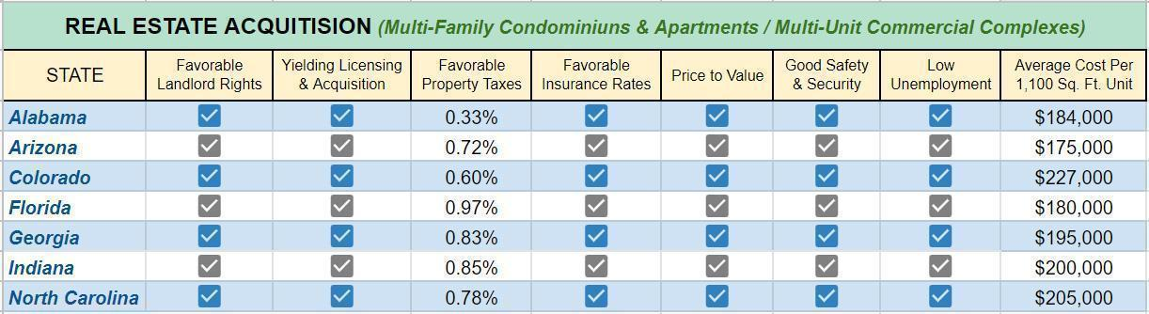
* http://www.tax-rates.org/taxtables/property-tax-by-state
* https://www.mashvisor.com/blog/best-states-for-landlords-2022/
* https://www.newhomesource.com/mls_com

How Stakeholders May Participate

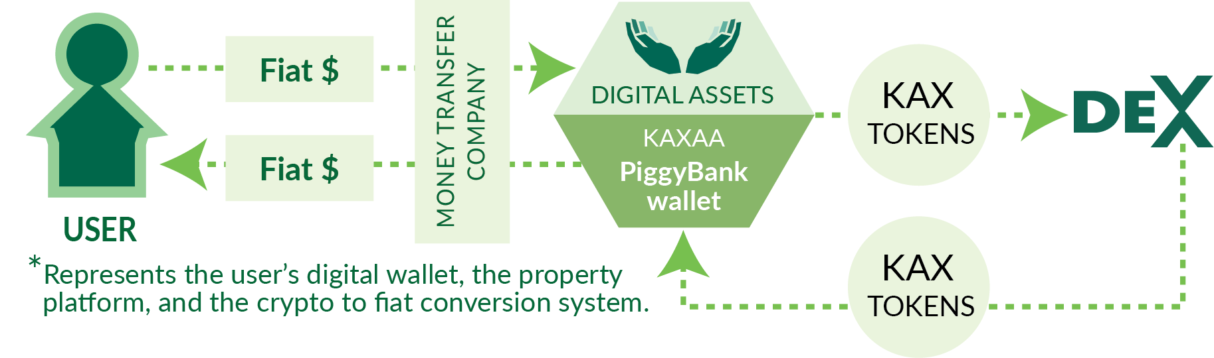
Above: simplified overview of the Kaxaa Platform

Regulatory Compliance Reduces Risk


Kaxaa will Strictly Abide by the Fair Housing Act
Kaxaa will abide by The Fair Housing Act, 42 U.S.C. 3601 et seq., which prohibits discrimination by direct providers of housing, such as landlords and real estate companies as well as other entities, such as municipalities, banks or other lending institutions and homeowners insurance companies whose discriminatory practices make housing unavailable to persons because of: race or color, religion, sex, national origin familial status, or disability.

KYC: a Kaxaa Difference
Kaxaa will control and maintain a verifiable Know Your Customer (KYC) database stored and managed in the Kaxaa database. Most crypto projects avoid KYC and rely on total anonymity, but Kaxaa’s long-term value and near term difference will be merging the benefits of crypto anonymity and flexibility with the rigorous KYC and regulatory compliance world of real estate.

Compliance Greatly Reduces Participation Risk
Let’s face it; scams are everywhere and crypto projects have had their fill of fly-by-night “rug pulls'' where founders and others take off with the money. Kaxaa is not that. In fact, Kaxaa is working with and is known by financial regulators such as the United States Securities and Exchange Commission (“SEC”), the Federal Trade Commission (“FTC”) and state agencies in the state(s) of registration. The Kaxaa founders, its ultimate beneficiaries, and key team members are known by regulators and answer directly to government agencies. Kaxaa’s team is fully transparent and compliant and not attempting to hide behind systems to conceal identities or assets. This level of transparency is rare, if non-existant, in crypto spaces. Risks exist for any business venture and there are no guarantees of success with Kaxaa or any other project, but odds for success and long-term value are greatly increased when crypto and digital product founders work hard to be compliant and responsive to regulation as the Kaxaa team is.

Kaxaa KYC Chain
Kaxaa’s KYC Chain is the relationship between the primary Kaxaa data sources which stores and encrypts personal and sensitive KYC and financial data which is required for legal compliance. The Kaxaa KYC Chain connects to the blockchain Smart Contracts which are used to process transactions, payouts, and track and maintain loans. Kaxaa’s use of Smart Contracts and secure databases are publicly secure while, at the same time, immensely rich in data, property and market trend information, inferential data, and explicit KYC data which is validated for accuracy.

Glossary of Terms
$ (Dollars) - all references to “$” and amounts in “dollars” referred to herein are United States Dollars.
Contracts - traditional and digital Smart Contracts which provide the structure and support for the Kaxaa activities (see “Smart Contracts”)
Kaxaa Entities (Entity) - Wyoming Series Limited Liability Companies or other structures which are intended to expressly and solely hold real estate and other assets for the purposes of executing the Kaxaa project in a regulatory compliant manner.
Kaxaa Index - the proprietary patent-pending real estate and entity valuation system which is used to express real estate market health information as a single real number which is validated by third party auditors such as KPMG, BDO, and Deloitte.
Kaxaa KYC Chain - the KYC database which securely stores and encrypts transaction, contract, and regulatory data for regional and national compliance standards.
Kaxaa Platform or Platform (the “App”) - the functioning system and technologies which may include the Kaxaa Token, the Kaxaa Wallet, Smart Contracts, and opportunities to participate (not required and not available to all Kaxaa Token holders) in Kaxaa Entities which hold NFTs and real property (pending KYC, etc.). The Kaxaa Platform utility is to provide patent-pending Kaxaa Index data, market trends information, and property data which is analyzed and weighed to present itself in a manner which is personally curated to the end users who hold Kaxaa Tokens to access this profile specific data in near real time.
Kaxaa Token - the native utility token of the Kaxaa network, priced by supply and demand, used to access network functions priced with reference to the Kaxaa Index
Kaxaa Wallet - the secured digital storage and/or exchange system for Kaxaa elements which may include the Kaxaa Tokens, and other information.
Proof of Stake - the algorithm by which the Kaxaa blockchain network achieves distributed consensus. The forger of the next block is chosen via various combinations of random selection and Kaxaa wealth (“stake”). Proof of State is far more efficient and environmentally friendly than older “Proof of Work” methods of managing and validating blockchain ledger .
Smart Contracts - programs stored on the blockchain that run when predetermined conditions are met; typically used to automate the execution of an agreement so that all participants can be immediately certain of the outcome without any intermediary's involvement or time loss.
Utility Token - often called app coins or user tokens, provide users with future access to a product or service. Through Utility Token users can purchase future access to that service, often at a discount off finished products’ future market value or price.
Validators - Validators confirm access periods, and other conditions. Successful calculations allow Validators to forge new blocks to the chain.

Important Links
Kaxaa Website: https://Kaxaa.com
Kaxaa Twitter (X): https://twitter.com/Kaxaatoken/
Kaxaa Telegram: https://t.me/Kaxaatoken
Kaxaa Facebook: https://www.facebook.com/kaxaacoin
Kaxaa Instagram: https://www.instagram.com/kaxaa.token/
Kaxaa Bluesky: https://www.bsky.app/profile/kaxaatoken.bsky.social

Kaxaa Character ™

From “What is Blockchain? The most disruptive tech in decades” By Lucas Mearian, Senior Reporter, Computerworld on January 18, 2018.
Posted by the Forbes Agency Council on April 5, 2018. The FAC is an invitation-only community for executives in successful public relations, media strategy, creative and advertising agencies.
Iansiti, Marco; Lakhani, Karim R. (January 2017). "The Truth About Blockchain". Harvard Business Review. Harvard University. Archived from the original on 18 January 2017. Retrieved 17 January 2017.
Data retrieved from FRED, Federal Reserve Bank of St. Louis; https://fred.stlouisfed.org/
“Proof of Stake (PoS) concept states that a person can mine or validate block transactions according to how many coins he or she holds. This means that the more [altcoin] owned by a miner, the more mining power he or she has” as quoted from Investopedia (https://www.investopedia.com/terms/p/proof-stake-pos.asp).

